How to Test the Program

Testing Methods:

* + System: Linux (Ubuntu 18.04 64bits)
  + Environment requirements: install python 3 (python 2 is not supported)
  + Steps:
    1. Put simulator.py and machine code file in a single same directory:

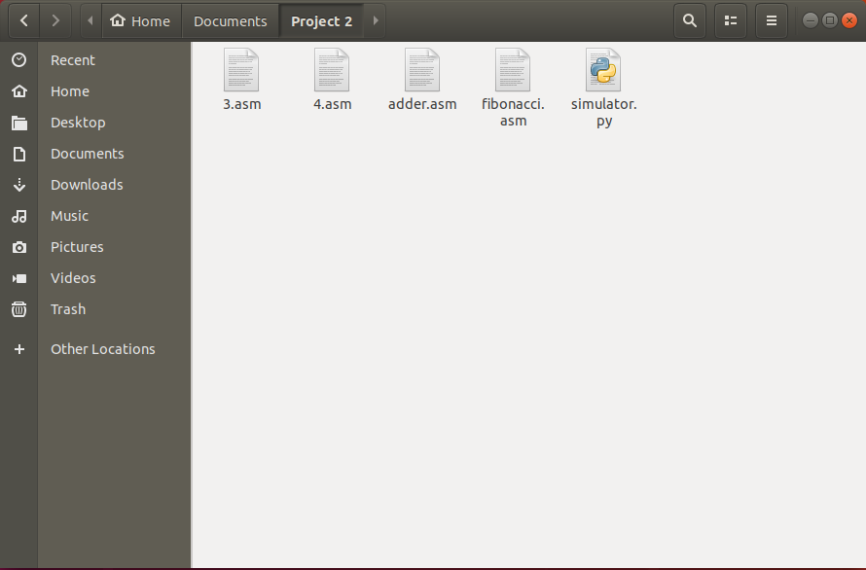

* + 1. In the same directory you put the files, right-click and select “Open in terminal”, in order to limit the directory. (Notice: using the terminal for whole system or open terminal in other directory is not allowed, otherwise the program will not be able to find the matching files. If you insist to do so, you have to considering limit the directory by yourself.)

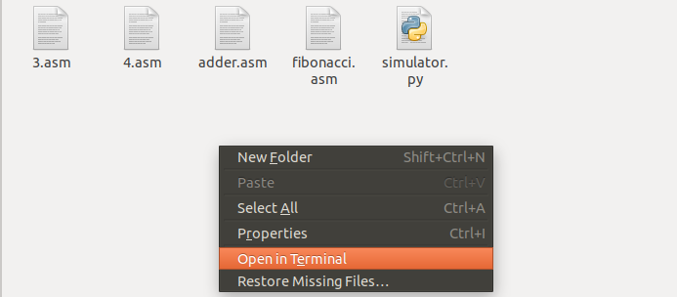

* + 1. In the terminal, type in “python3 simulator.py”.

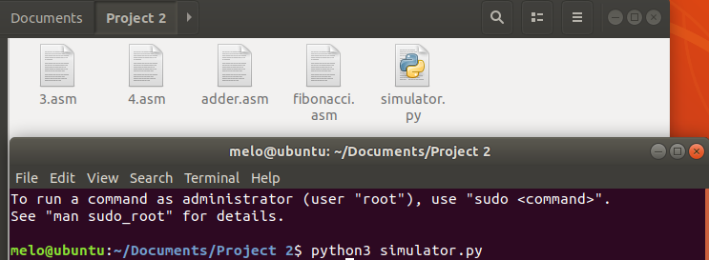

* + 1. Enter the correct machine code file name, if the input file name is wrong and the program can’t find it in the same directory, it will ask the user to input the machine code file name again.

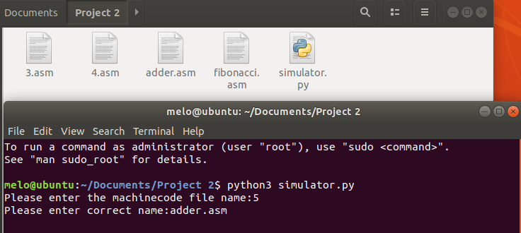

* + 1. Finally, it will execute the corresponding instructions.

